COMPREHENSIVE INTEGRATED MANAGEMENT PLAN
FOR THE MAYAGÜEZ BAY WATERSHED
RESEARCH PROGRAM

Quarterly Progress Report

Date of Report: 15 March 2004 For Quarter Ending: 29 February 2004
(nov/31, feb/28, may/31, aug/31)
Project No. CIMP-002

Project Title: Nutrient discharges from Mayagüez Bay Watershed __________

PI’s name: David Sotomayor Ramírez Telephone: 787-265-3851 x3734 Fax: 787-265-0860 email: david_sotomayor@cca.uprm.edu

Project Status: _x_ On Schedule __Suspended __Delayed __Cancelled __ Completed

Percentage of Work Completed: __50 % (year)_____ Completion Deadline: 31 August, 2003_____

The applicant is requesting that an extension be granted for this CIMP project through ____/____/____.
(Please attach project extension justification.)

Activities progress: (According to Work Schedule submitted with application)
Task  # | Major Activity | Date Started | Estimated Date of Completion | Date Completed | % Complete | Dependant on Task(s):
1 | Surface Water Resources and Geographical Information System | 9/01 | 6/04 |  | 85
2 | Nutrient, sediment, and bacterial quantification (base flow) | 5/02 | 12/03 |  | 95
3 | Nutrient, sediment, and bacterial quantification (storm events) | 8/03 | 6/04 |  | 60
4 | Analysis and interpretation of water quality data (relate trends in water-quality parameters to land use, hydrologic discharge, point and non-point sources) | 1/03 | 7/04 |  | 40 | 1,2,3
5 | Quantify nutrient (total N, total P, DRP) export coefficients from watersheds | 1/03 | 7/04 |  | 85 | 1,2,3,4
6 | Apply a model of an indicator of actual P transport (the P index developed by USDA-NRCS) to selected farms within the subwatersheds | 1/04 | 7/04 |  | 25

Summary of Progress on Project this Quarter: See attached report after this sheet.
(Attach additional sheet, if necessary)
- Surface water resources and GIS
We are in the process of recopilating the precipitation database from Mayagüez Airport (Lat/Lon 18.15N 67.09W), Maricao Fish Hatchery (Lat/Long 18.10N 66.59W), and San Sebastián (Lat/Long 18.21N 67.01W).

The hydrologic program HEC-1 of US Army Corps of Engineers as interface to the WMS program was used to establish Peak discharge-recurrence interval relationships for Miraflores (previously known as Cercada) and Cerro Gordo subwatersheds. We used probable mean annual 24-hr precipitation corresponding to recurrence intervals of 2, 5, 10, 25, 50 and 100 yrs. Analysis of low-flow characterístics and flow-duration characteristics is being performed.

We have concluded the land-use map for the five subwatersheds. The results are presented in Table 1. Animal units within Cerro Gordo subwatersheds have been accounted for, but has not yet been included in the database.

Table 1. General description of five subwatersheds selected for nutrient and pathogen characterization within the Rio Grande de Añasco watershed for 2002-2003.

 | Sub Watershed
 | Cercada |  | Cerro Gordo |  | Cerrote |  | Chamorro |  | Guaba
Land use Type | Area (ha) | (%) | Area (ha) | (%) | Area (ha) | (%) | Area (ha) | (%) | Area (ha) | (%)
Urban | 25.8 | 11.5 | 8.0 | 1.1 | 8.6 | 2.9 | 2.4 | 0.6 | 17.6 | 1.3
Agricultural | 8.6 | 3.9 | 144.6 | 20.2 | 25.9 | 8.8 | 39.8 | 10.0 | 153.6 | 11.6
Rangeland | 51.7 | 23.1 | 96.3 | 13.5 | 34.5 | 11.8 | 23.4 | 5.9 | 141.1 | 10.7
Forest | 137.8 | 61.5 | 393.5 | 55.1 | 224.3 | 76.5 | 331.7 | 83.5 | 1007.7 | 76.3
Pasture (1) | 0.0 | 0.0 | 0.0 | 0.0 | 0.0 | 0.0 | 0.0 | 0.0 | 0.0 | 0.0
Pasture (2) | 0.0 | 0.0 | 72.3 | 10.1 | 0.0 | 0.0 | 0.0 | 0.0 | 0.0 | 0.0
Total | 224.0 |  | 714.7 |  | 293.3 |  | 397.3 |  | 1320.0
Housing units | 560 |  | 776 |  | 435 |  | 433.0 |  | 975.0

2. Nutrient and bacterial quantification

We have concluded analysis for most of the water-quality parameters. The analysis for 16 september to 16 December 2004 (7 sampling dates) for DRP, TP, and TKN has been performed and are awaiting results. Partial temporal trends for all water quality analyses are presented in Figures 1 through 12. Figure 13 presents frequency distribution of bacterial indicators. Samples for ammonium and nitrate in water have not been performed.

Figure 1. Trends in stream-water pH in five subwatersheds within the Rio Grande de Añasco watershed.
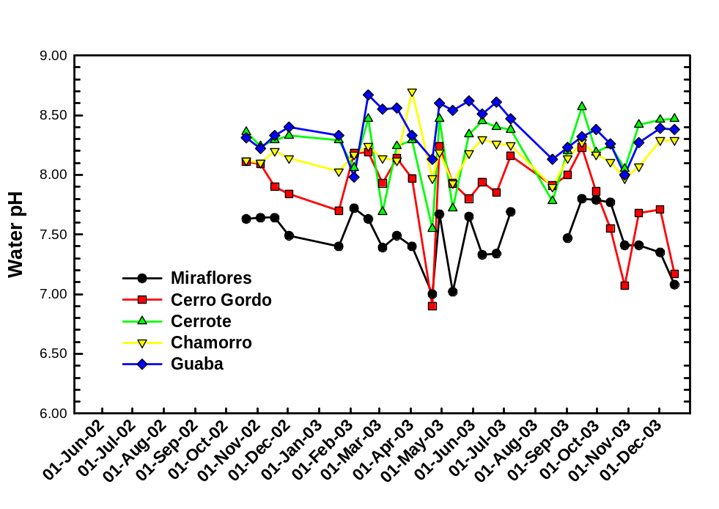

Figure 2. Trends in stream-water electrical conductivity in five subwatersheds within the Rio Grande de Añasco watershed. 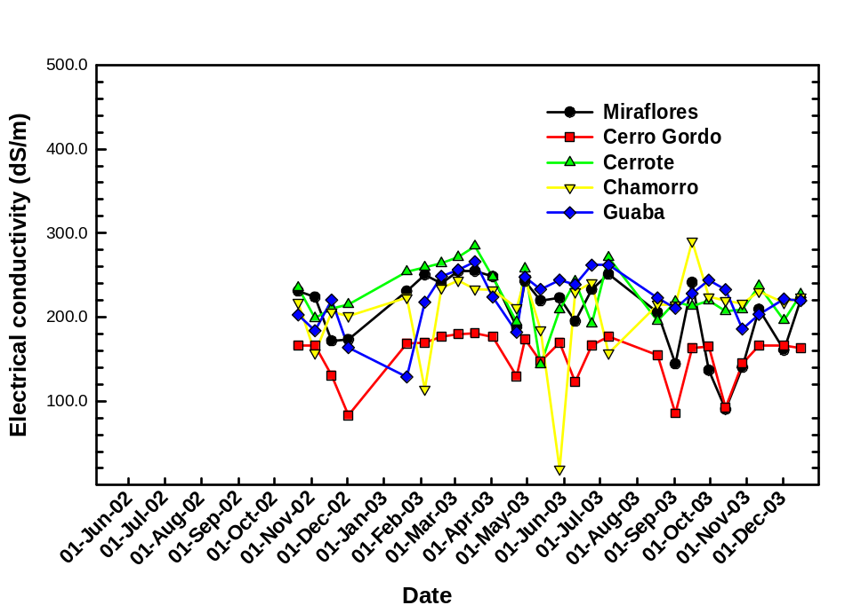

Figure 3. Trends in hydrologic discharge in five subwatersheds within the Rio Grande de Añasco watershed.
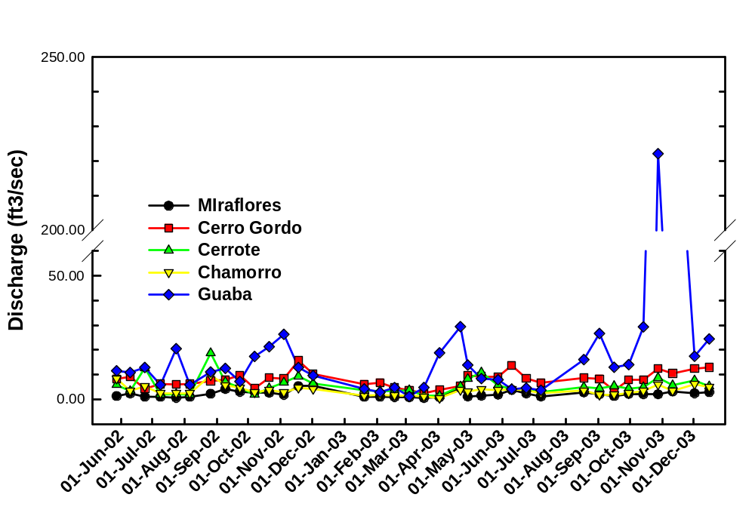
Figure 4. Trends in stream-water suspended sediments in five subwatersheds within the Rio Grande de Añasco watershed.
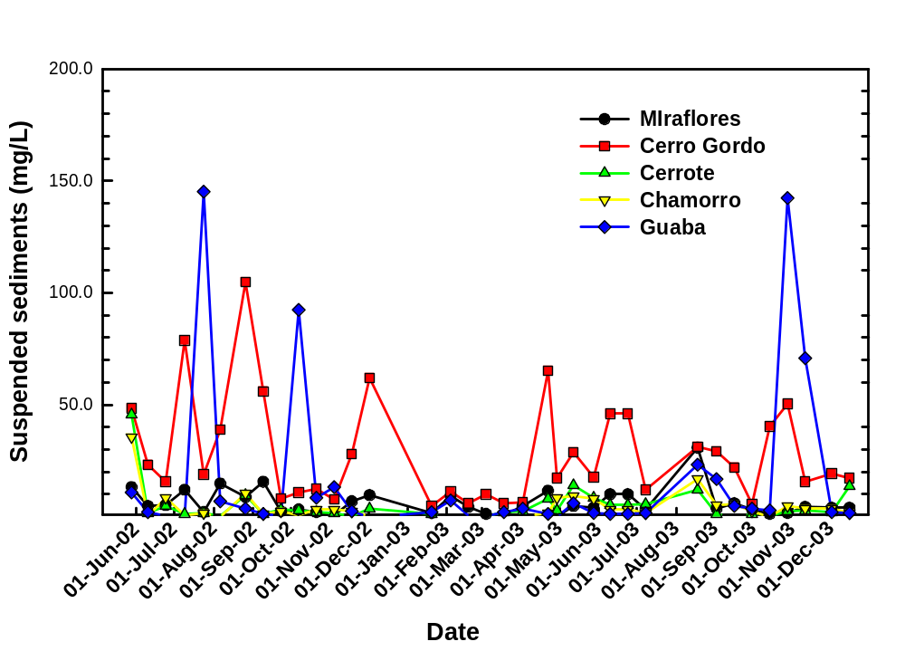
Figure 5. Trends in stream-water dissolved reactive P in five subwatersheds within the Rio Grande de Añasco watershed.
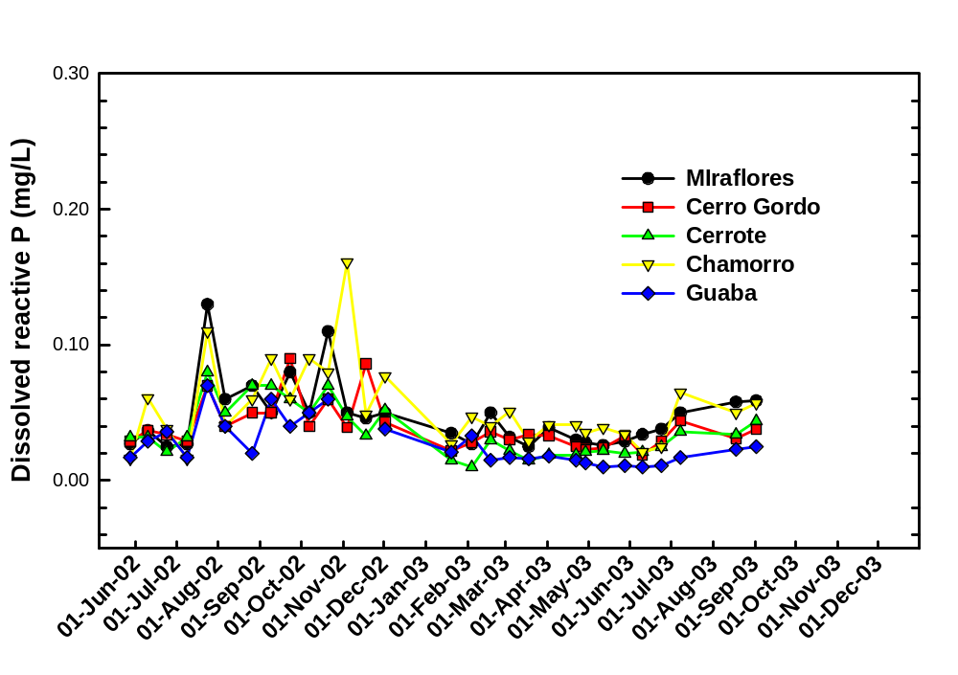

Figure 6. Trends in stream-water total P in five subwatersheds within the Rio Grande de Añasco watershed.
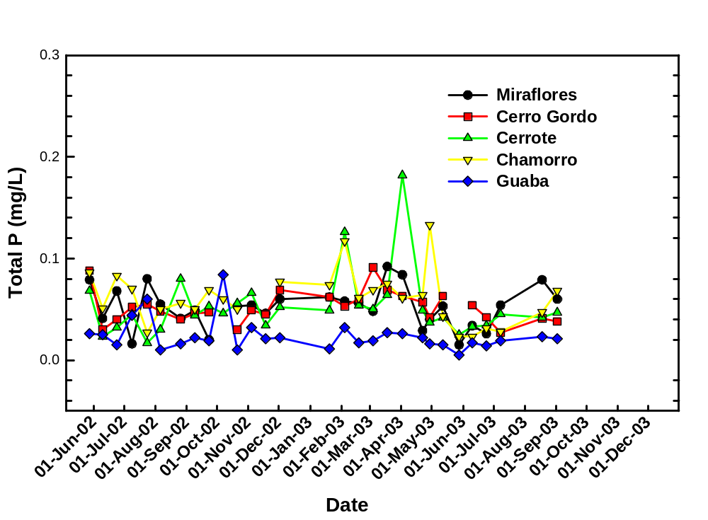
Figure 7. Trends in stream-water total kjeldahl N in five subwatersheds within the Rio Grande de Añasco watershed.
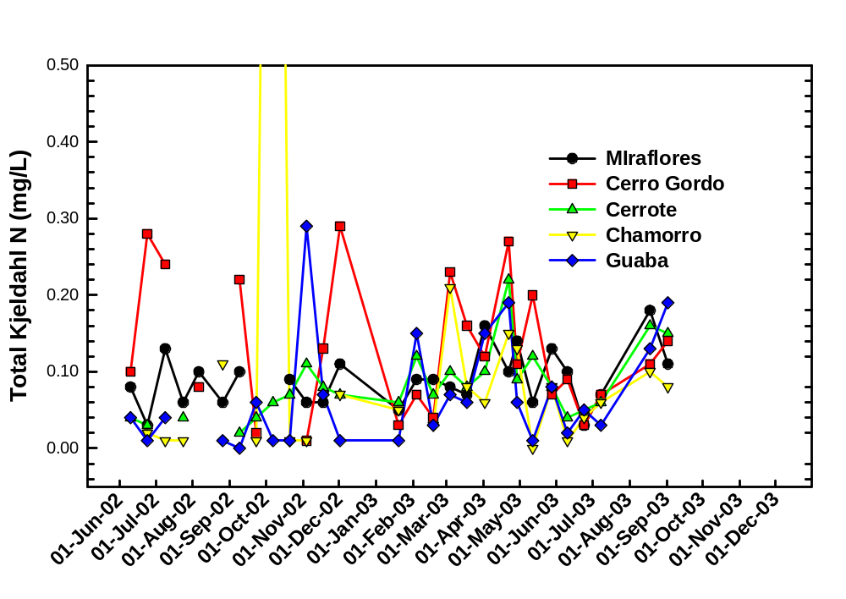
Figure 8. Trends in stream-water chlorophyll a in five subwatersheds within the Rio Grande de Añasco watershed. 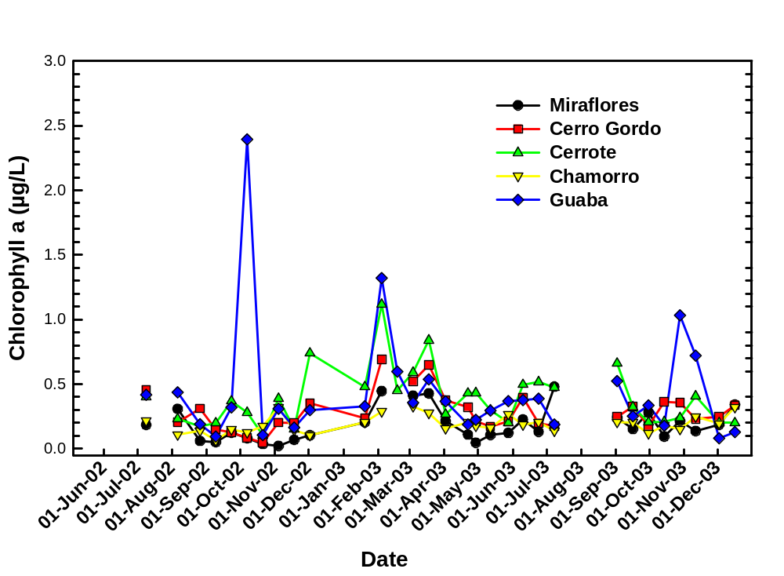
Figure 9. Trends in stream-fecal coliform counts in five subwatersheds within the Rio Grande de Añasco watershed.
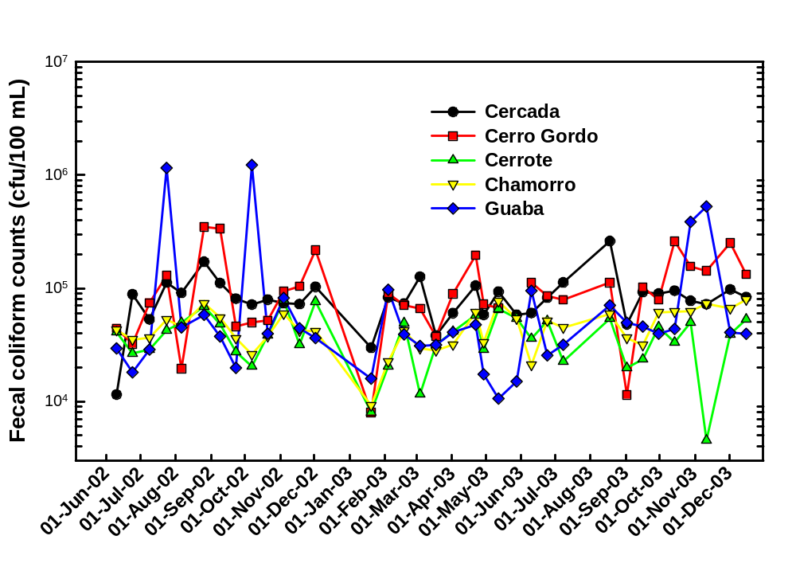
Figure 10. Trends in stream-E. coli counts in five subwatersheds within the Rio Grande de Añasco watershed.
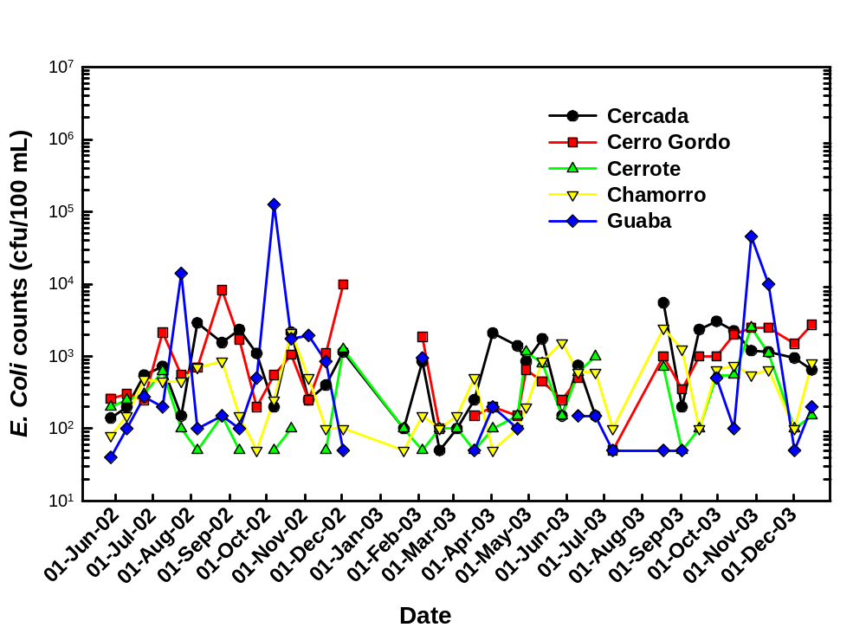

Figure 11. Trends in stream-total coliform counts in five subwatersheds within the Rio Grande de Añasco watershed.
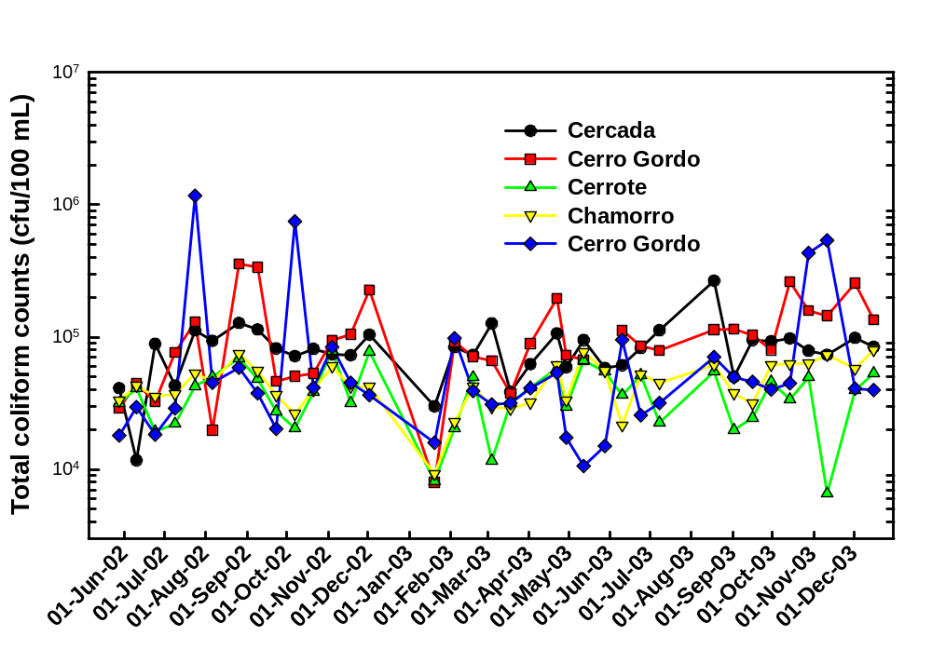

Figure 12. Trends in stream-Enterococcus counts in five subwatersheds within the Rio Grande de Añasco watershed.
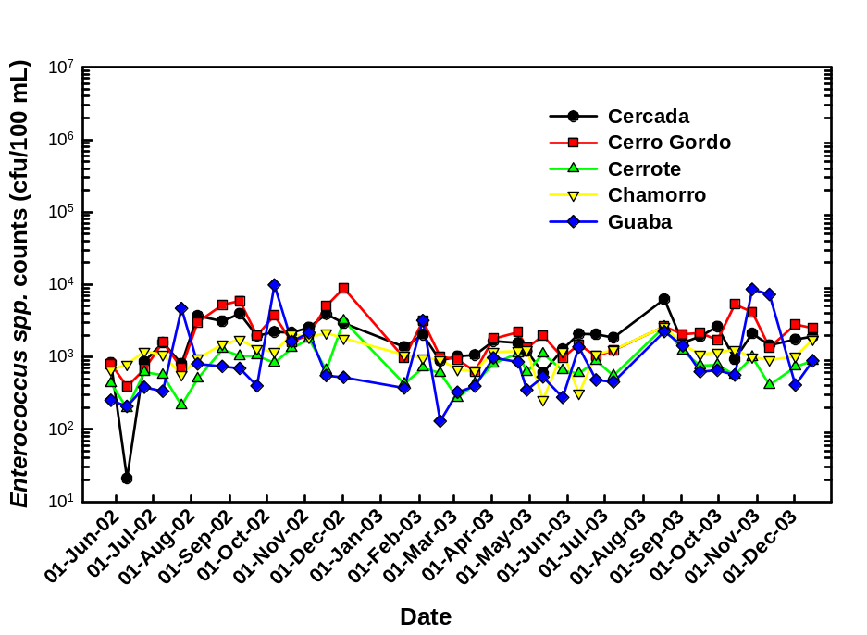
Figure 13. Frequency distribution of bacterial indicators in five subwatersheds within the Rio Grande de Añasco watershed.
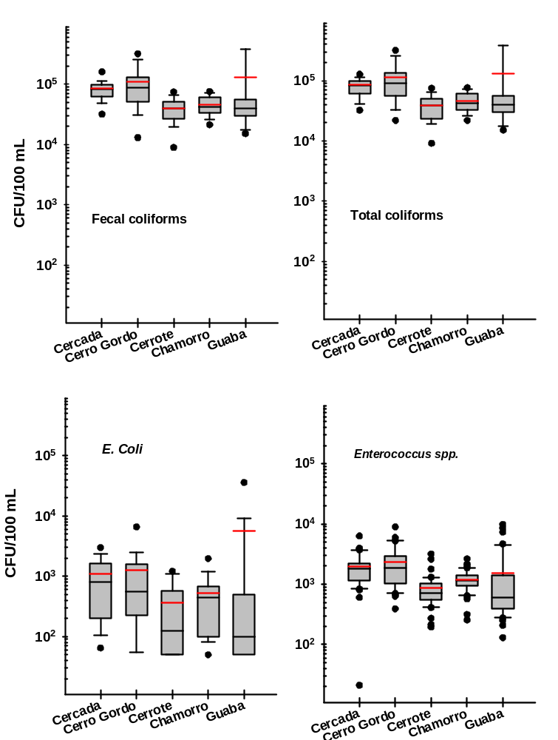
Two ISCO 3000 Automatic Storm Event Samplers have been installed at Cercada and Cerro Gordo subwatershed in Añasco. Storm event sampling has been performed from August to December 2003. Seventeen storm event were collected in Cercada watershed from 16 september 2003 to 14 December 2003. The events lasted from 30 minutes to a maximum of two hours. To date no more events have been collected.

Table 2. Summary statistics of hydrologic flow per event and concentrations are presented below: `
 | Volume | Suspended sediments | Total P | Dissolved P | TKN
 | ft³ | mg/L
Mean | 39219 | 1376 | 0.080 | 0.051 | 3.40
Stdev | 50897 | 1318 | 0.027 | 0.021 | 1.80
Range |  | 86.40 - 5065 | 0.040 – 0.109 | 0.010 – 0.078 | 2.72 – 7.08
The number of data points (n) for flow, suspended sediments, total P, dissolved P, and TKN are 17, 17, 8, 8, 8, respectively.

Table 3. Summary statistics of sediment, phosphorus, and nitrogen loads are given below:
 | Suspended sediments | Total P | Dissolved P | TKN
 | kg
Mean | 2983 | 0.074 | 0.036 | 7.62
Stdev | 7672 | 0.080 | 0.024 | 15.32
Sum | 50714 | 0.594 | 0.290 | 60.98

3. Analysis and interpretation of water quality data

Table 4. Correlation among bacterial indicators and water-quality parameters collected during an 18-month period in five subwatersheds of the Rio Grande de Añasco watershed ¹.
Parameter | Fecal coliforms | E. coli | Total coliforms | Enterococcus
Suspended sediments | 0.452 (0.001) | 0.312 (0.001) | 0.443 (0.001) | 0.413 (0.001)
Discharge | 0.267 (0.002) | 0.2423 (0.003) | 0.284 (0.001) | 0.321 (0.001)
Dissolved P | 0.267 (0.002) | 0.242 (0.004) | 0.284 (0.001) | 0.321 (0.001)
Total P | NS | NS | NS | NS
TKN | NS | NS | NS | NS
Chlorophyll a | 0.200 (0.01) | NS | 0.0173 (0.030) | NS
pH | -0.458 (0.001) | -0.342 (0.001) | -0.468 (0.001) | -0.473 (0.001)
Electrical conductivity | -0.356 (0.001) | -0.290 (0.001) | -0.427 (0.001) | -0.449 (0.001)
Temperature | NS ² | NS | NS | NS
Fecal coliforms | - | - | - | -
E. coli | 0.536 (0.001) | - | - | -
Total coliforms | 0.973 (0.001) | 0.551 (0.001) | -
Enterococcus | 0.686 (0.001) | 0.521 (0.001) | 0.719 (0.001) | -

1 Bacterial counts, suspended sediments, and hydrologic discharge data were log₁₀ transformed prior to analysis.
2 NS denotes non-significance at P<0.05

4. Quantify nutrient export coefficients from subwatersheds

Table 5. Seasonal estimate (May 2002 to February 2003) of suspended sediments and dissolved reactive P contribution from five subwatersheds in the Rio Grande de Añasco watershed. Dissolved P data includes data up to October 2002 only.
Subwatershed | Suspended sediments |  | Dissolved P
 | kg | kg/ha | FWMC (µg/L) | Conc. (µg/L) | kg | kg/ha
Cercada | 11,560 | 47.6 | 64.9 | 61.8 | 51.6 | 0.213
Cerro Gordo | 174,352 | 133 | 48.2 | 48.2 | 243.9 | 0.187
Cerrote | 18,219 | 123 | 52.4 | 50.9 | 62.1 | 0.420
Chamorro | 13,454 | 102 | 57.8 | 60.9 | 33.9 | 0.255
Guaba | 184,274 | 210 | 42.3 | 40.9 | 139 | 0.159

Problems Encountered and/or Assistance Needed:
(Attach additional sheet, if necessary)

Certification:
As the Principal Investigator, I certify that the information contained within this quarterly report accurately reflects the status of this CIMP project.

___________________________________________________________________________________
Principal Investigator Signature & Title Date

CIMP Project Authorized Representative Use Only
Funding Status: ___ Unchanged ___ Overruns ___ Underruns
Funds Expended to Date $______________ Anticipated Cost Overruns/Underruns: $_____________
Payment Request this Quarter: $_______________ Payment Received this Quarter: $_____________

Project Extension Authorization:
Based upon our review of the supporting documentation, the requested project extension is justified. The project director authorize an extension of this project through _____/_____/_____.

_____________________________________________________________
Director’s Signature Date

